Pandas basicAssignment Questions

Assignment

Q1. Create a Pandas Series that contains the following data: 4, 8, 15, 16, 23, and 42. Then, print the series.

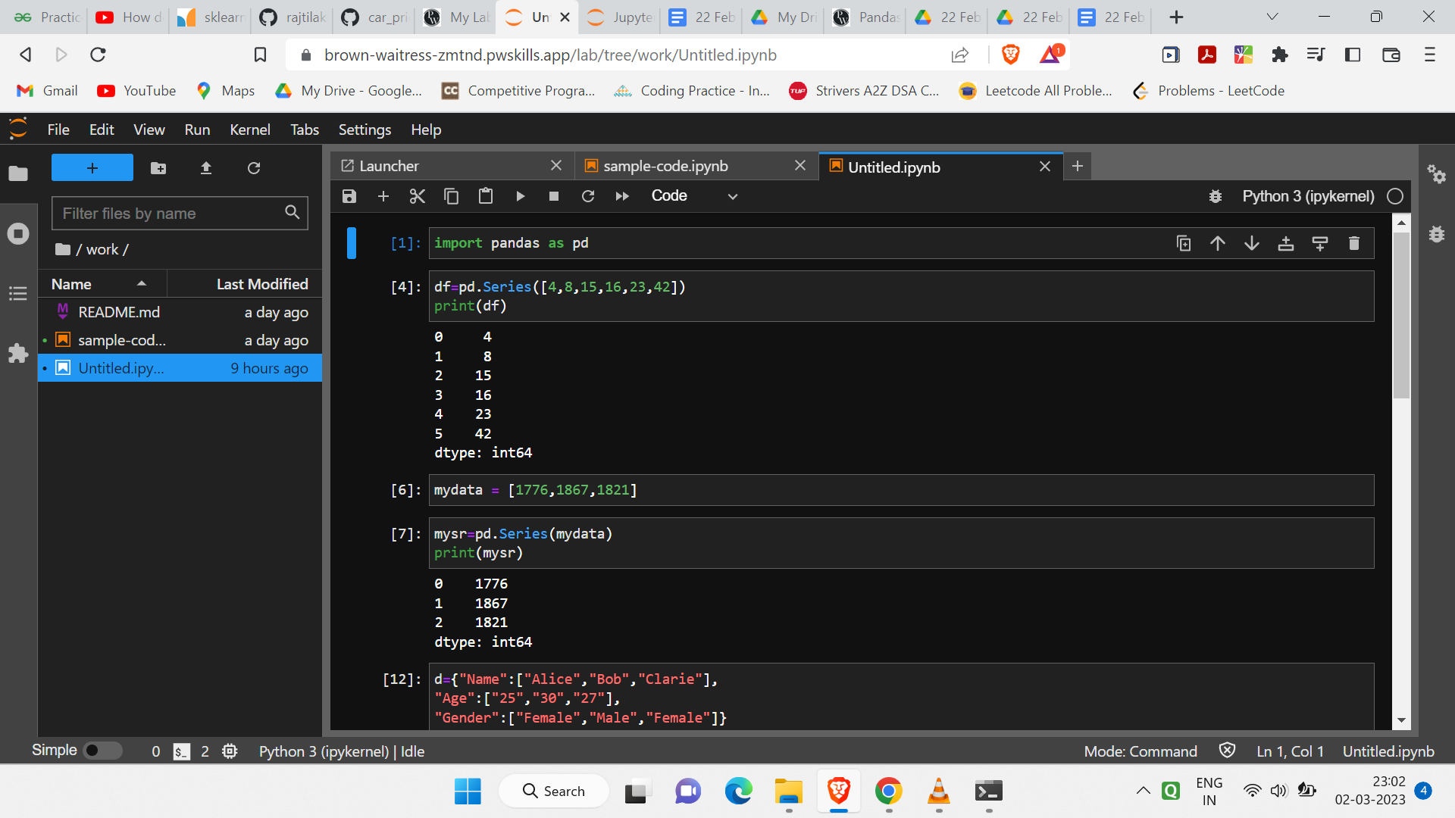

Q2. Create a variable of list type containing 10 elements in it, and apply pandas.Series function on the variable print it.

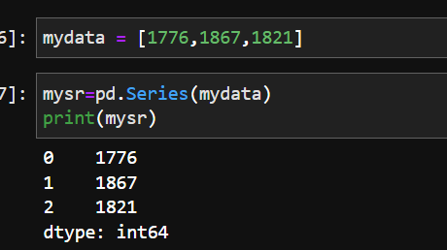

Q3. Create a Pandas DataFrame that contains the following data:

Name

Alice

Bob

Claire

Then, print the DataFrame.

Age 25

30

27

Gender Female Male

Female

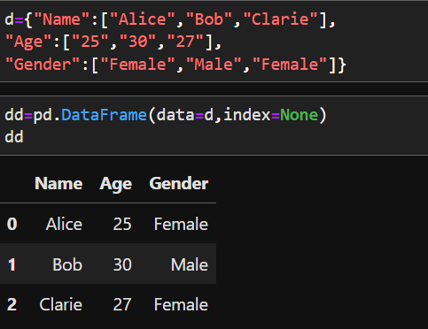

Q4. What is ‘DataFrame’ in pandas and how is it different from pandas.series? Explain with an example.

A-4)Pandas DataFrame, on the other hand, is a two-dimensional structure with columns and rows whose size can be changed. You can also think of it as a dictionary of Series objects. The data parameter can take any of the following data types: Dictionary (dict) of – 1D ndarray, lists, or Series

Q5. What are some common functions you can use to manipulate data in a Pandas DataFrame? Can you give an example of when you might use one of these functions?

Q6. Which of the following is mutable in nature Series, DataFrame, Panel?

Q7. Create a DataFrame using multiple Series. Explain with an example.

Note:  Create your assignment in Jupyter notebook and upload it in GitHub & share that github repository link through your dashboard. Make sure the repository is public.

Data Science Masters